Project Design Phase-II
Data Flow Diagram & User Stories

Date | 29.09.2026
Team ID | 6AP3D7136F290BE8A6B32917
Project Name | AI FAQ ASSISTANT API
Maximum Marks | 4 Marks

Data Flow Diagram (DFD)
External Entities:
- Public User
- Authenticated User
Main Process:
- AI FAQ Assistant API
Data Stores:
- User Collection
- FAQ Collection
External Service:
- Google Gemini AI
Main Data Flows:
- Registration/Login details → API
- JWT Authentication → Authenticated User
- FAQ request → API
- FAQ data ↔ FAQ Collection
- User data ↔ User Collection
- Question/Topic → Gemini AI
- AI Answer / Generated FAQ → API
- JSON Response → User

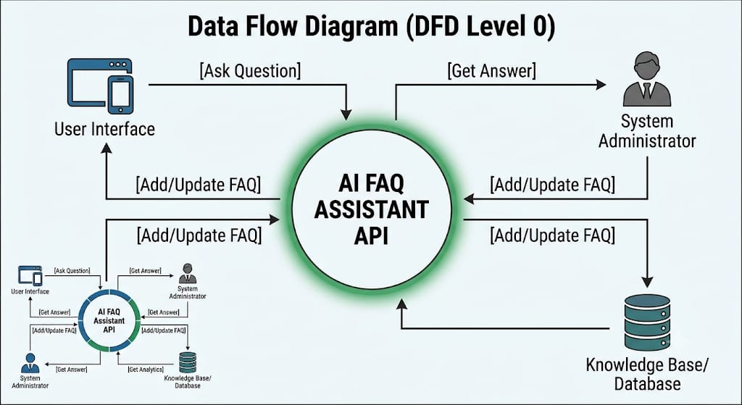

User Stories
User Type | Functional Requirement (Epic) | User Story Number | User Story / Task | Acceptance Criteria | Priority | Release
Public User | FAQ Management | USN-1 | As a user, I can view all available FAQs. | All available FAQ records are displayed successfully. | High | Sprint-2
Public User | FAQ Management | USN-2 | As a user, I can view an individual FAQ using its ID. | The selected FAQ is returned using a valid ID. | High | Sprint-2
Public User | FAQ Search | USN-3 | As a user, I can search FAQs using a keyword. | Matching FAQ records are returned for the supplied keyword. | High | Sprint-3
Authenticated User | Registration | USN-4 | As a user, I can register using my name, email and password. | A new user account is created and the password is securely hashed. | High | Sprint-1
Authenticated User | Login | USN-5 | As a user, I can login using my email and password. | Valid credentials generate a JWT authentication token. | High | Sprint-1
Authenticated User | User Profile | USN-6 | As an authenticated user, I can access my profile information. | The authenticated user's profile information is returned. | Medium | Sprint-1
Authenticated User | FAQ Management | USN-7 | As an authenticated user, I can create an FAQ. | FAQ is created with question, answer and valid category. | High | Sprint-2
Authenticated User | FAQ Management | USN-8 | As an authenticated user, I can update my own FAQ. | Only the FAQ creator can update the FAQ successfully. | High | Sprint-2
Authenticated User | FAQ Management | USN-9 | As an authenticated user, I can delete my own FAQ. | Only the FAQ creator can delete the FAQ successfully. | High | Sprint-3
Authenticated User | AI Services | USN-10 | As an authenticated user, I can generate an AI answer for a question. | Gemini AI returns an answer for the submitted question. | High | Sprint-3
Authenticated User | AI Services | USN-11 | As an authenticated user, I can generate FAQ question-and-answer pairs from a topic. | Gemini AI generates a structured question-and-answer pair. | High | Sprint-4
Authenticated User | Security | USN-12 | As a user, I can access protected APIs only after authentication. | Requests without a valid JWT are rejected. | High | Sprint-4
System User | Validation & Error Handling | USN-13 | As a system, I can validate request data and handle API errors. | Invalid requests return structured error responses. | Medium | Sprint-4

